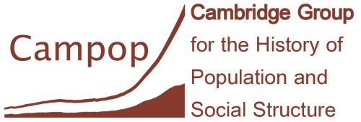
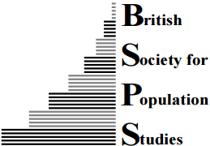
===========================================================================

‘Plagues and Peoples Revisited’ Workshop, Cambridge, 23-24 March 2020
The workshop will be held at Newnham College on Monday 23rd March (registration 10.00 -10.30 am) and at Robinson College on Tuesday 24th March 2020.
The workshop is free to attend. Buffet lunches and refreshments, and the drinks reception are also provided free. However attendees wishing to attend the conference dinner will need to book and pay in advance (£40 for waged, £25 for students and unwaged).
If you wish to attend only one day of the workshop then please indicate this on the form.
Please indicate your requirements by ticking the relevant boxes below:
 | Please tick
Workshop sessions 10.30 am – 6 pm 23 March
Workshop sessions 9 am – 1 pm 24 March
Interdisciplinary networking session 2 – 3.30 pm 24 March
Buffet lunch Monday 23 March
Drinks reception Monday 23 March 6 - 7 pm
Workshop dinner Monday 23 March
Buffet lunch Tuesday 24 March
Special dietary requirements: | Yes/No
Please state special diet needs …………………………………………..
Please state any special drink requirements ……………………….
I would like to be considered for a flash talk

Name (as you would like it to appear on name badge) ………………………………………………….
Institution (as you would like it to appear on name badge) ………………………………………………….
Confirm email address to be used ...........................................
We cannot arrange accommodation for you, but B&B accommodation can be booked in Cambridge colleges at competitive rates at https://www.universityrooms.com/en-GB/search/in/cambridge

PLEASE COMPLETE THE NEXT PAGE OF THE FORM, TO INDICATE YOUR INTERDISCIPLINARY INTERESTS
Interdisciplinary interests
Please indicate which areas you conduct research in, and which areas or techniques you would like to know more about.
Topics and methods | I work in this area | I would like to know more about
Historical periods of interest (e.g. 19th century)
Geographical areas of interest (e.g. Japan)
Diseases of interest (e.g. smallpox)
Anthropology
Bioarchaeology
Economic and social history
Epidemiology
Evolutionary biology
Geography
Historical demography
Mathematics
Medical history
Medicine
Public health
Zoology
Ancient DNA
Agent-based modelling
Anthropometry
Archival research
Bioarchaeology
Demographic and econometric modelling
Historical climate patterns
Mathematical modelling of infectious diseases
Mixed methods
Nutrition
Oral histories, interview and survey data
Spatial modelling and Geographical Information Systems (GIS)

Please send the completed form as soon as possible and by 1st February to Sophy Arulanantham, Senior Clerk and Outreach Co-ordinator, Campop sja60@cam.ac.uk
If you wish to be considered for a flash talk (of 5 minutes in length) then please submit a title and abstract by February 1st.

